# SDN Practical 1

## Step1: Create The topology

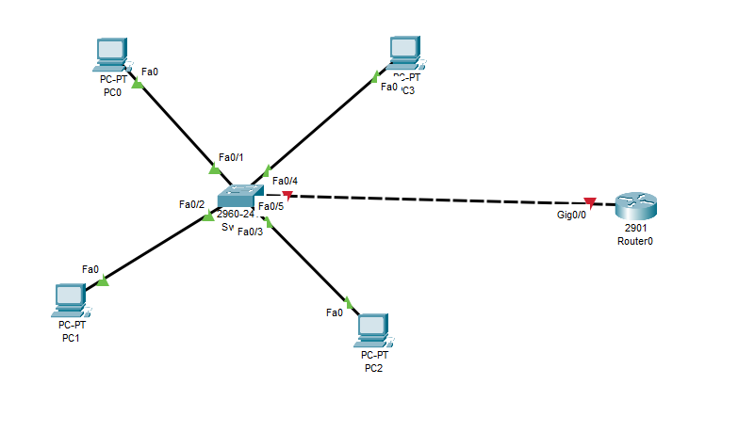

Now assign the ip address, desktop -> ip address

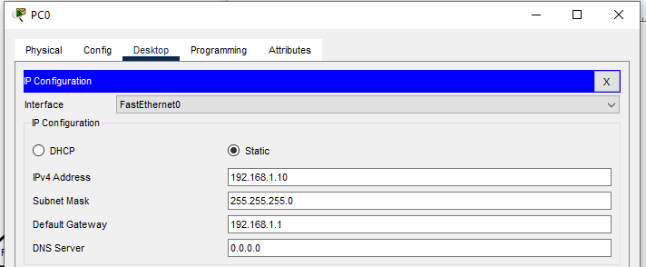

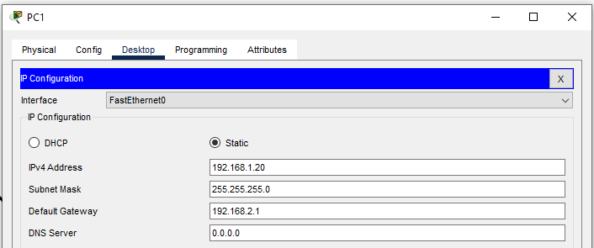

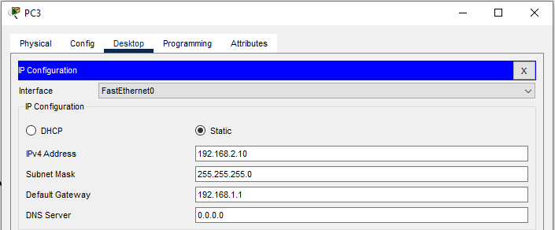

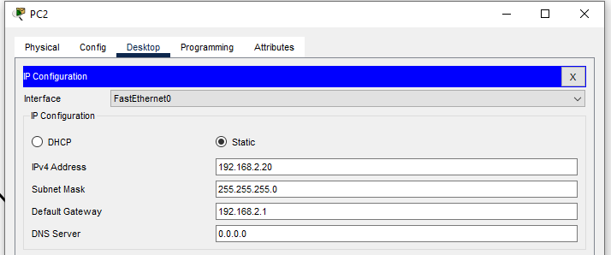

## Step 2 - create the vlans

Go to switch, click on switch, CLI mode, we have to enable the switch and once it is enabled w will get hash so we need to get enable and conf

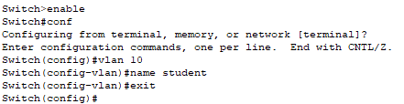

Exit and go to vlan 20



## Step 3 - Assign the ports to VLAN

We are having 4 ports   
Giving to first pc, fa0/1

Now give access to that port with the command switchport mode access

Now we have the access to the port



Now go to the next port fa0/2

They still can’t communicate, because we have created the security – VLAN  
Similarly put the things another ports, fa0/3 ko 10 me put karna h and fa0/4 ko 20 me

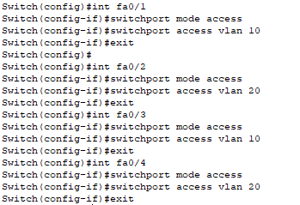

If its is LAN devices will talk to each other but when VLAN devices will not talk , so we need to trunk…

And then save it, by running command “do write”

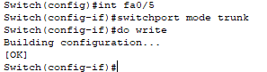

## Step 4 - Configure the Router

Click on router, go to CLI, use enable and go to config mode

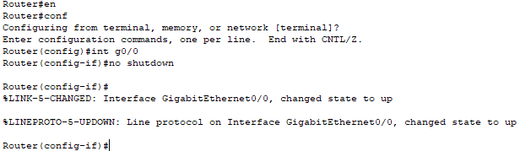

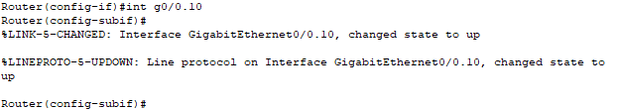

This would allow the traffic to go



Because we need to do unmasking



Now do the same

And use 0.20

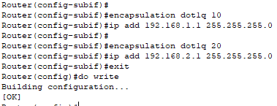

Now check connectivity using ping command

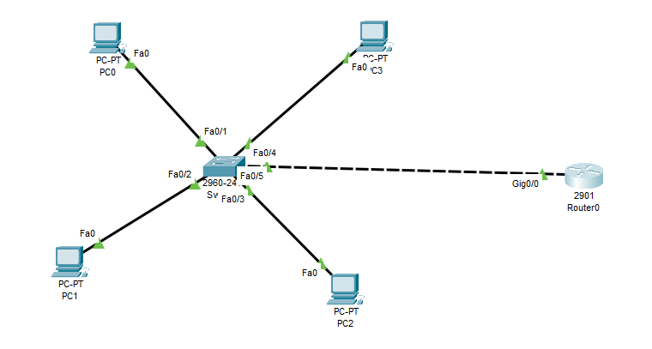

Repeat for everyone:  
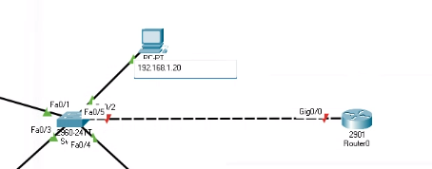

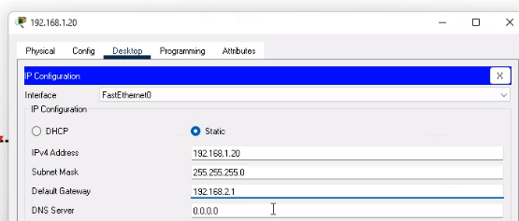

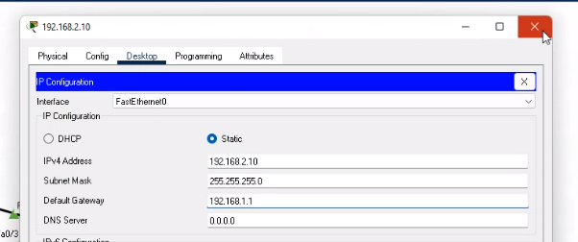

Step 2 - create the vlans

Go to switch, click on switch, CLI mode, we have to enable the switch and once it is enabled w will get hash so we need to get enable and conf



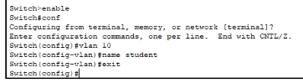

Exit and go to vlan 20

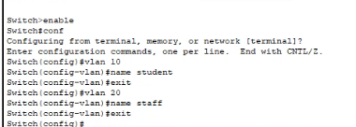

Step 3 - Assign the ports to VLAN

We are having 4 ports   
Giving to first pc, fa0/1

Now give access to that port with the command switchport mode access

Now we have the access to the port



Now go to the next port fa0/2



They still can’t communicate, because we have created the security – VLAN  
Similarly put the things another ports, fa0/3 ko 10 me put karna h and fa0/4 ko 20 me

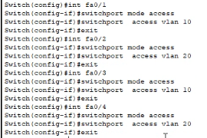

If its is LAN devices will talk to each other but when VLAN devices will not talk , so we need to trunk…

And then save it, by running command “do write”

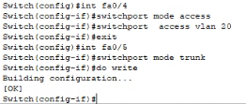

Step 4 - Configure the Router

Click on router, go to CLI, use enable and go to config mode

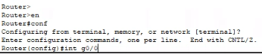

And start it by using command”no shutdown”

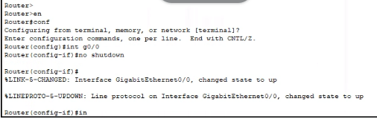

Int - interface

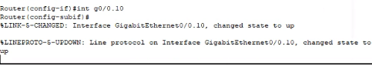  
This would allow traffic to go

To encapsulate the traffic – encapsulation dot1q 10



Using masking



Now do the same

And use 0.20

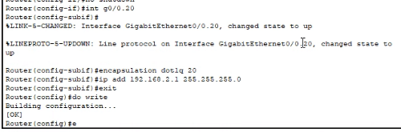

Check connectivity using ping command